**Comparison of ARIMA and Winters Methods on Sales Forecasting of Furniture Companies at UD Podomoro Asahan**

**Ledya Frischa1, Dr. Rina Filia Sari, M.Si.2, Dr. Ismail Husein, M.Si.3**

1,2,3Department of Mathematics, Universitas Islam Negeri Sumatera Utara, Medan, Indonesia

**Article Info**

***Article history:***

Received mm dd, yyyy

Revised mm dd, yyyy

Accepted mm dd, yyyy

***Keywords:***

*Forecasting, ARIMA, Winters, Master Production Schedule.*

**ABSTRACT**

Along with economic growth in Indonesia, the need for household furniture is also increasing, including furniture. This makes furniture companies compete to produce products according to consumer demand. Therefore, the company conducts sales forecasting to determine the development of sales so that sales can be optimal. The purpose of this research is to solve the problem of increasing or decreasing sales of windows and doors furniture from July 2021 to June 2022 and making a production schedule based on the forecasting results obtained. The data of this research are sales of windows, doors, window frames, and door frames at UD. Podomoro Asahan from July 2016 to July 2021. The data were processed using the ARIMA and Winters methods and then compared between the two methods.

The results of the research using the ARIMA method the model used for window sales is ARIMA (0,1,1) with MPE -0.079772% and MAPE 16.592778% error values. For door sales forecasting, the model used is ARIMA (0,1,1) with MPE -0.318423% and MAPE 43.437804% error values. The results of research using the Winters method, the smoothing constant used for forecasting window sales is ***α***=0.546225; ***β***=0.259846; ***γ***=0.116178; with MPE -0.39785% and MAPE 39.78471% error values. For forecasting door sales, the smoothing constant used is ***α***=0.254329; ***β***=0.023969; ***γ***=0.142605; with MPE -0.2562% and MAPE 35.10514% error values.

***Corresponding Author:***

Ledya Frischa,

Department of Mathematics,

Universitas Islam Negeri Sumatera Utara, Medan, Indonesia

Email: ledyafrischa07@gmail.com

1. **INTRODUCTION**

Industry is a field or economic activity related to the processing of raw materials or the manufacture of finished goods in factories using skills and labor and the use of tools in the field of processing produce, and its distribution as a main activity.

UD. Podomoro Asahan is one of the furniture manufacturers in Tanjung Balai which was established in 2010. As for the types of furniture produced by UD. Podomoro Asahan namely: windows, doors, window frames and door frames. Since the increase in the number of furniture orders in 2015, the number of furniture sales in UD. Podomoro Asahan has increased. However, with the increase in the level of demand, consumers have to wait a long time for the furniture requested. So it often makes consumers disappointed and even cancels requests. This makes sales on UD. Podomoro is not optimal because it should be UD. Podomoro can get more benefits. With the increase in the level of sales, it makes UD. Podomoro must forecast sales so that the level of sales can be optimal.

Therefore, forecasting aboutnamount of furniture sales is important for the company so that the company can prepare for the needs to anticipate an increase in the number of sales, such as raw materials, labor, and other supporting equipment.

Based on sales data obtained, the amount of furniture sales in UD. Podomoro Asahan shows *trend* pattern so the methods used to forecast the number of sales in the future are ARIMA and *Winters.*Every method forecasting sure produce an error. *Mean Percentage*Error (MPE) and *Mean Absolute Pencentage Error*(MAPE) are measuring instruments used to calculate the error of forecasting results. So, from the results of each forecasting will be condensed to find out, compare and test the differences between the two forecasts. Forecasting is said to be accurate when the MPE and MAPE values are small.

The result of in this final task m will be made reference in the manufacture *Master Production Schedule* (MPS). The purpose of making MPS is to regulate the production process furniture and regulate the resources nowned by the company so that it is able meet the needs furniture accordingto the results of forecasting.

Formulation of thenproblem which is the main in this study is how to determine the appropriate forecasting to project furniture sales on UD. Podomoro Asahan.

The benefit of this study is that can be used as a reference m in producingjfurnitur for the next one year. The results of the study can be used to look at the possible increases and decreases in furniur sales over the next one year.

1. **LITERATURE REVIEW**

Forecasting is a process of predicting an up coming event and is important in efficient and effective planning. Forecasting is an art and science of predicting future events (Tholib, 2016). Forecasting is also a process to estimate several future needs which include needs in order to meet the demand for goods or services (Nasution, 2016).

Other opinions, forecasting is the art and science of predicting future events by involving taking historical data and projecting it into the future with a systematic approach model (Heizer, 2011). Based on the explanation above, it can be concluded that forecasting is a technique for testing conditions in the past to predict future conditions based on existing facts.

1. **RESEARCH METHODS**

This type of research includes observational research, namely non-experimental quantitative research because the data collected by making observations or observations without the need for treatment. This as applied research, because tries to apply *forecasting method* in the field of industry, namely the sale of furniture products.

The type of data used in this study is secondary data in the form of furniture sales data which is recorded monthly. The source of the data obtained in this study is sourced from data on furniture sales at UD. Podomoro Asahan from July 2016 to June 2021 (there are 60 sales data whichjhereinafter referred to 60 pointsnhistorical data). The variable nused in this is the window.

The processing of data that isused in forecasting this, both with the ARIMA method and with then *winters* method is carried out with the help of application Minitab and Ms. Excel.

1. ExplorejData
2. StagejARIMA Method

The data that has is processed through five stages that according to with the forecasting ARIMA, namely:

* Plotting Data
* Temporary Model
* Model Parameters
* Diagnostic Examination
* Use Model for Forecasting

1. Stages *Method Winters*

The data five stages, including:

* Identifying the Model
* Determining Initial Value of Parameter
* Determining Value of Constant Smoothing
* Calculating Forecast ValuejOriginal Data
* Forecasting Future Periods

1. Comparing Error ValuejForecasting

At this stage, acomparison of error values is carried out using tests MAPE (Mean Absolute Percentage Error) and MPE (*Mean Percentage Error* to find out which *n* forecasting.

Prosedur carried out in the implementation of researchnstarts from initial stage formulation problem and goal setting to the finalnstage conclusions and suggestions. The stages that used in thisjstudy can seen in block diagramj***Figure 3.1.***

Analysis of Forecasting Result

Study ofnLiterature

MPS Creation

Data Collection

MPS Implementation

Analysis and Determination of Data Patterns

Conclusions and Recommendations

Forecasting Technique Selection

Preparation of Final Project Report

Sales Forecast

Forecasting Testing

Done

Not Accurate Accurate

**Gambar 3.1 Blok Diagram Prosedur Penelitiaan**

1. **RESULTS, ANALYSIS, AND DISCUSSION**

Sales data of windows recorded in UD. Podomoro Asahan from July 2016 to June 2021 as shown in the table below:

**Table 4.1 Sales Data**

|  |  |  |  |  |  |  |  |  |  |  |  |  |  |
| --- | --- | --- | --- | --- | --- | --- | --- | --- | --- | --- | --- | --- | --- |
| Year | Month to month | | | | | | | | | | | |  |
| 7 | 8 | 9 | 10 | 11 | 12 | 1 | 2 | 3 | 4 | 5 | 6s |
| 2016-2017 | 142 | 146 | 135 | 139 | 133 | 140 | 158 | 147 | 114 | 121 | 168 | 194 | 1737 |
| 2017-2018 | 183 | 187 | 153 | 181 | 174 | 139 | 144 | 112 | 140 | 123 | 154 | 157 | 1847 |
| 2018-2019 | 111 | 178 | 198 | 147 | 209 | 152 | 167 | 119 | 145 | 148 | 194 | 109 | 1877 |
| 2019-2020 | 129 | 167 | 170 | 214 | 175 | 127 | 176 | 131 | 183 | 211 | 145 | 221 | 2049 |
| 2020-2021 | 176 | 158 | 137 | 194 | 207 | 222 | 187 | 168 | 136 | 145 | 197 | 132 | 2059 |

1. **Forecasting with ARIMA Method**
2. **Data Stationaryity Check**

Plot trend analysis of window sales data in UD. Podomoro Asahan for the period of July 2016 to June 2021 as shown in the figure below.

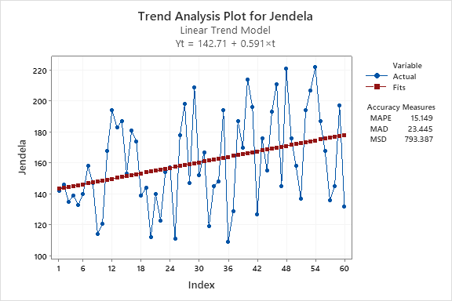

**Figure 4.1 Window Analysis Trend Plot**

It is known from figure 4.1 that the data pattern indicates an uptrend and it can also be seen that the spread of data points is not constant so it can be said that the window sales data in UD. Podomoro Asahan for the period of July 2016 to June 2021 is not stationary. It can be proved by determining the average value of Window sales:









With

X(transformation)= variable already changed

X = variables to change

● = exponent of the variable to be changed

The data does not show any fluctuations around the value of 159.4833, but rather the data continues to rise and shows a trend pattern. The following *Box-Cox* plot window sales data for the period July 2016 to June 2021.

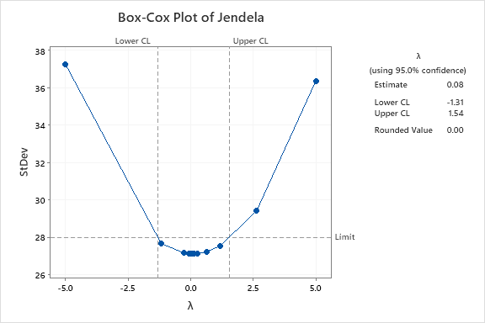

**Figure 4.2 Box-Cox Plot of Window**

A data is said to be stationary in *variance*if the value of  is worth 1 or passes 1 (Aritonang, 2009). Because the *lambda* value () is 0.00, it must first be transformed so that the data becomes stationary in *variance*.

The results of the transformation with the Box-Cox Plot method using the minitab application are shown in Figure 4.3 below.

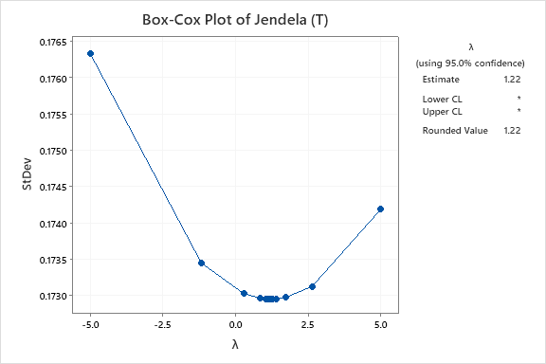

**Figure 4.3 Box-Cox Transformation Plot of Windows**

In Figure 4.3 shows that the *rounded value*(☹) is 1.22 with a 95% confidence interval. Because the acquisition of the *lambda* value () has passed 1, it indicates that the data is already stationary in *variance*.

Further more,an examination of the accuracy of the data in *means* is carried out by creating ACF and PACF plots. Performed using the minitab application.

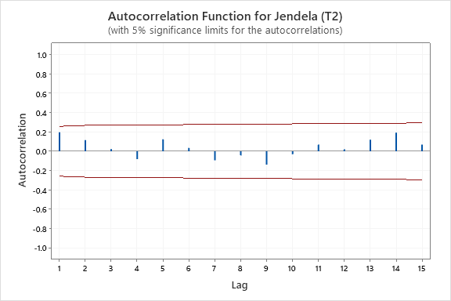

**Figure 4.4 Plot ACF of Windows (T2)**

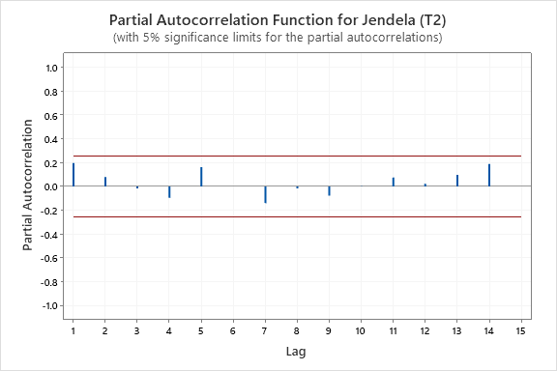

**Figure 4.5 Plot PACF Windows (T2)**

Analyze the ACF plot by the formula:





Analyze the PACF plot by the formula:



In Figure 4.4 and Figure 4.5, neither the ACF nor PACF plots show any *cuts off*or *dies down*, so it can be said that the periodic series data of window sales are not stationary in terms of *means*. To clarify, it can be seen from the *Trend Analysis Plot*below.

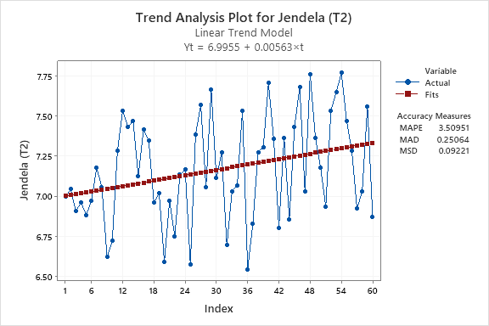

**Figure 4.6 Window Analysis Trend Plot (T2)**

From the trend analysis plot above, it can be seen that the data still tends to have trend patterns. Therefore, the data must be differentiated at the first order. The results of first-order differentiation are as shown in Figure 4.7 and Figure 4.8.

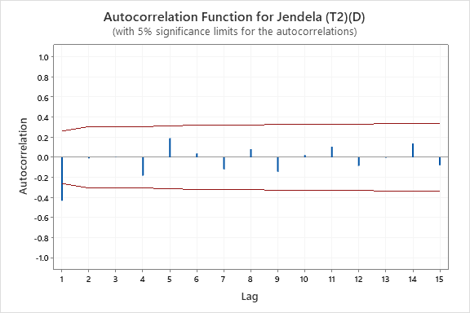

**Figure 4.7 Plot ACF Windows (T2)(D)**

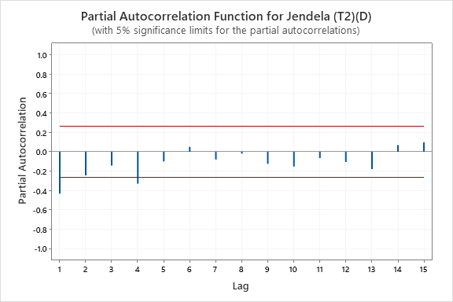

**Figure 4.8 Plot PACF Windows (T2)(D)**

The ACF plot in Figure 4.7 shows cuts off at *lag* 1, while in Figure 4.8 the PACF plot shows *cuts off*at *lags* 1 and 4. Therefore, the periodic series data of window sales are already stationary after first-order differentiation. Data differentiation can also be calculated manually by using the formula:



For t1=0

t = 2, 3, 4, ..., 60 obtained:





The data shows fluctuations at -0.00212 as shown in Figure 4.9. With this the data is declared stationary because there are no more trend patterns.

*The differencing* value is used to determine the value of I (*integrated*) in the ARIMA model (Aritonang, 2009). If:

1. *Differencing* is done 1 time, then the value of I is equal to 1
2. *Differencing*is done 2 times, then the value of I is equal to 2, and so on.

But in general, data that is not yet stationary will become stationary with a process of *differencing* 2 times. If the data is stationary without *any differencing* process, then the value of I is equal to zero, and the *Box-Jenkins* model that can be formed is AR, MA, or ARMA.

Here is Figure 4.9 which is a *trend analysis plot* which shows that the data from the results of the first level of differentiation do not represent any trends.

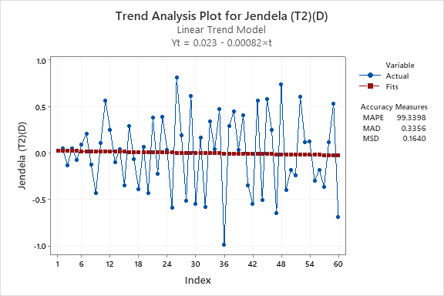

**Gambar 4.9 Trend Analysis Plot of Windows (T2)(D)**

1. **Temporary Model Identification (*Tentative*)**

The window sales data becomes stationary after differentiating on the first order, so automatically the *value of d*is 1 which means the temporary ARIMA model i.e. (p,1,q). Then the determination of the AR (*Autoregressionve*) or *p*and MA (*Moving Average*or *q*orders using ACF and PACF values from the periodic series data that have been stationary.

From the ACF plot in Figure 4.8, it can be seen that the *cuts off* are located at *lag* 1, which can form a temporary model with an MA aspect. While from the PACF plot in Figure 4.9, it can be seen that *the cuts off* are located at *lags*1 and 4, which can form a temporary model with an AR aspect.

Thus, the provisional ARIMA models obtained are: ARIMA (1,1,0); ARIMA (4,1,0); ARIMA (0,1,1); ARIMA (1,1,1); and ARIMA (4,1,1).

1. **Estimation of Model Parameters**
2. ARIMA (1,1,0)

*The estimated output* of the ARIMA model (1,1,0) is as follows.

**Table 4.2 Estimated ARIMA Model Parameters (1,1,0)**

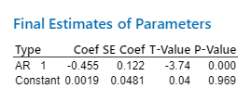

From Table 4.2 it can be seen that:

1. AR value 1

Found *T-value= -*3.74. Since |-3.74|>2.145 then the parameter *φ*1 = -0.455 is significant at *a*5%.

1. *Constant* Value

Found *T-Value*= 0.04. Due to |0.04| <2.145 then the *constant* parameter = 0.0019 is insignificant at *a*5%.

The *constant*value is insignificant at *a*5%, so the ARIMA equation (1,1,0) is parameter *φ*1.

1. ARIMA (4,1,0)

*The estimated output* of the ARIMA model (4,1,0) is as follows.

**Table 4.3 ARIMA Model Parameter Estimation (4,1,0)**

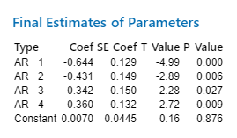

From Table 4.3 it can be seen that the *constant*value is insignificant at *a*5%, so the ARIMA equation (4,1,0) is *the* parameters φ 1, φ 2.φ 3, and *φ*4.

1. ARIMA (0,1,1)

*The estimated output* of the ARIMA model (0,1,1) is as follows.

**Table 4.4 ARIMA Model Parameter Estimation (0,1,1)**

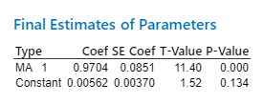

From Table 4.4 it can be seen that the *constant*value is insignificant at *a*5%, so the ARIMA equation (0,1,1) is parameter **1.

1. ARIMA (1,1,1)

*ARIMA* model estimation output (1,1,1) as follows.

**Table 4.5 ARIMA Model Parameter Estimation (1,1,1)**

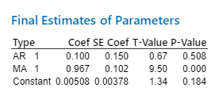

From Table 4.5 it can be seen that the AR value of 1and *the constant*value is insignificant at *a*5%, so the ARIMA equation (1,1,1) is parameter **1.

1. ARIMA (4,1,1)

*The estimated output* of the ARIMA model (4,1,1) is as follows.

**Table 4.6 Estimated ARIMA Model Parameters (4,1,1)**

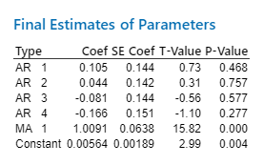

From Table 4.6 it can be seen that the values of AR 1, AR 2, AR 3, and AR 4are not significant at *a*5%, so the ARIMA equation (4,1,1) is the parameter **1and *the constant* parameter.

1. **Diagnostic Examination**

At this stage, it is divided into 3 stages, namely: test the significance of the model parameters, test white *noise*on residual and test normality.

1. ARIMA Model (1,1,0)
2. Parameter Significance Test

**Table 4.7 Estimated parameters of the ARIMA model (1,1,0) without constants**

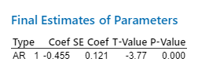





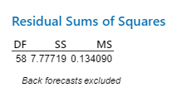

From Table 4.7 it can be seen that the P-Value of the AR parameter 1 = 0.000 which means that the *P-Value*<*a*(0.05) so *that H0* is accepted, signifying the parameter has been significant against *the* model.

1. *White Noise*

**Table 4.8 ARIMA Ljung-Box Modifications (1,1,0)**

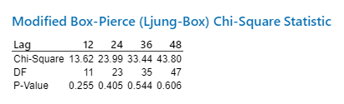

From Table 4.8 it can be seen that *P-Value*>*a*(0,05) so H 0 is accepted, indicating residual *white noise*in ARIMA (1,1,0).

1. Normality Test

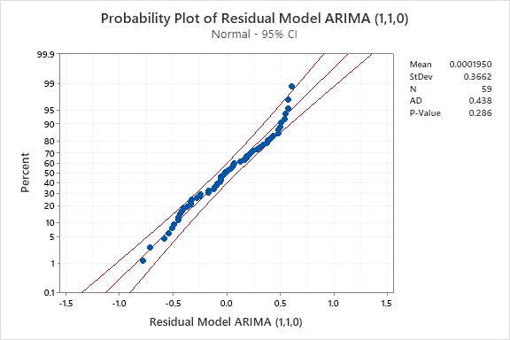

**Figure 4.10 ARIMA Residual Probability Plot (1,1,0)**

From Figure 4.10 it can be seen that the P-Value on the ARIMA residual probability plot (1,1,0) = 0.286 which means that *P-Value*>a(0.05) signifies *a* normally distributed residual.

Similar was done to ARIMA (4,1,0); ARIMA (0,1,1); ARIMA (1,1,1); and ARIMA (4,1,1) so summarized in Table 4.9.

**Table 4.9 Summary of Diagnostic Examination Results**

|  |  |  |  |  |
| --- | --- | --- | --- | --- |
| **Type** | **Significant** | ***White Noise*** | **Normality** | **Conclusion** |
| **ARIMA (1,1,0)** | Significant to the model | Residual *white noise* | Normally distributed residuals | All fulfilled |
| **ARIMA (4,1,0)** | Significant to the model | Residual *white noise* | Normally distributed residuals | All fulfilled |
| **ARIMA (0,1,1)** | Significant to the model | Residual *white noise* | Normally distributed residuals | All fulfilled |
| **ARIMA (1,1,1)** | Insignificant to the model | Residual *white noise* | Normally distributed residuals | Unfulfilled |
| **ARIMA (4,1,1)** | Insignificant to the model | Residual *white noise* | Normally distributed residuals | Unfulfilled |

The following is a comparison of the *Mean Squared Error*(MSE) summarized from the results of the model parameter significance test *output* with the Minitab application to get the best model.

**Table 4.10 Comparison of MSE Values of Each Model**

|  |  |  |
| --- | --- | --- |
| **Type** | **MSE value** | Conclusion |
| **ARIMA (1,1,0)** | 0,134090 |  |
| **ARIMA (4,1,0)** | 0,114800 |
| **ARIMA (0,1,1)** | 0,104522 | Smallest MSE value |
| **ARIMA (1,1,1)** | 0,104000 | Did not pass diagnostic tests |
| **ARIMA (4,1,1)** | 0,131852 |

From the summary of diagnostic examination results in Table 4.9, it can be seen that the ARIMA models that meet the three tests are: ARIMA (1,1,0); ARIMA (4,1,0); and ARIMA (0,1,1). Meanwhile, of the three ARIMA models that meet the three tests, the one with the smallest MSE value is ARIMA (0,1,1) as stated in Table 4.10. That is, the ARIMA model is best for forecasting window sales in UD. Podomoro Asahan is an ARIMA model (0,1,1).

1. **Best Models for Forecasting**

**Table 4.11 Window Sales Forecasting Results with ARIMA (0,1,1)**

|  |  |  |  |  |
| --- | --- | --- | --- | --- |
| **Year** | Moon | Forecast Results | Lower Confidence Level (LCL) | Upper Confidence Level (UCL) |
| **2021** | July | 176,809 | 119,541 | 234,077 |
| August | 177,366 | 120,070 | 234,662 |
| September | 177,923 | 120,599 | 235,247 |
| October | 178,480 | 121,129 | 235,832 |
| November | 179,037 | 121,658 | 236,417 |
| December | 179,595 | 122,188 | 237,001 |
| **2022** | January | 180,152 | 122,717 | 237,586 |
| February | 180,709 | 123,247 | 238,171 |
| March | 181,266 | 123,776 | 238,756 |
| April | 181,823 | 124,306 | 239,341 |
| May | 182,380 | 124,835 | 239,925 |
| June | 182,937 | 125,365 | 240,510 |

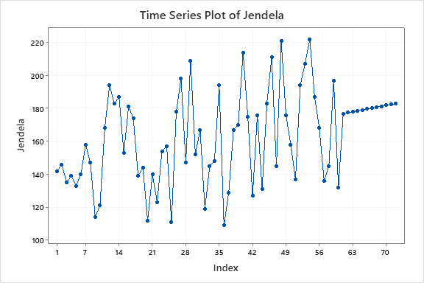

**Figure 4.11 Plot of Window Sales Original Data and Forecasting Results**

Furthermore, the forecasting results in Table 4.19 are evaluated to determine the average error in percent using Mean Percentage Error (MPE) and *Mean Absolute Percentage Error* (MAPE).The data used to get MPE and MAPE is the last 1 year data, namely July 2020-June 2021.

**Table 4.12 Evaluation of Window Sales Forecasting Results with ARIMA Model (0,1,1)**

|  |  |  |  |  |  |  |
| --- | --- | --- | --- | --- | --- | --- |
| Moon | Forecast Results | Lower Confidence Level (LCL) | Upper Confidence Level (UCL) | Original Data 2020-2021 | PE (%) | APE (%) |
| 7 | 176,809 | 119,541 | 234,077 | 176 | -0,00459659 | 0,459659 |
| 8 | 177,366 | 120,070 | 234,662 | 158 | -0,12256962 | 12,256962 |
| 9 | 177,923 | 120,599 | 235,247 | 137 | -0,29870803 | 29,870803 |
| 10 | 178,480 | 121,129 | 235,832 | 194 | 0,8000000 | 8,000000 |
| 11 | 179,037 | 121,658 | 236,417 | 207 | 0,13508696 | 13,508696 |
| 12 | 179,595 | 122,188 | 237,001 | 222 | 0,19101351 | 19,101351 |
| 1 | 180,152 | 122,717 | 237,586 | 187 | 0,03662032 | 3,662032 |
| 2 | 180,709 | 123,247 | 238,171 | 168 | -0,07564881 | 7,564881 |
| 3 | 181,266 | 123,776 | 238,756 | 136 | -0,33283824 | 33,283824 |
| 4 | 181,823 | 124,306 | 239,341 | 145 | -0,25395172 | 25,395172 |
| 5 | 182,380 | 124,835 | 239,925 | 197 | 0,07421320 | 7,421320 |
| 6 | 182,937 | 125,365 | 240,510 | 132 | -0,38588636 | 38,588636 |
| .MPE | | | | | -0,07977212 | 16,592778 |
| MAPE | | | | | |

From the evaluation table of forecasting results with ARIMA (0,1,1) above, it can be seen that the MPE value is -0.07977212% and the MAPE value is 16.592778%.

1. **Forecasting by the Winters Method**
2. **Model Identification**

By looking at Figure 4.1, it is known that window sales data in July 2016 – June 2021 has a trend pattern that tends to increase and has a seasonal pattern. From the pattern of ups and downs in sales data, it is concluded that the seasonal effect is seasonal additives.

1. **Determine the Initial Estimated Value**

The level value is obtained by calculating the average value of the sales results of the first 1 year. The trend value in the first 1 year is still zero. Meanwhile, the *seasonal* value is obtained from the results of reducing seat sales data by level. From the calculation, the level, trend, and *seasonal* values below.

























1. **Calculating the Forecast Value of the Original Data**













1. **Defining the Smoothing Constant**

The value of the smoothing constant is determined by the rule of each value smaller than 1 and greater than 0. At this stage, it is done using the *solver* in Ms. Excel. Based on the *solver* results, *alpha*, *beta* and *gamma* values were obtained as well as low MPE and MAPE values as shown in the table below.

**Table 4.21 Window Forecasting Smoothing Constants**

|  |  |  |  |  |
| --- | --- | --- | --- | --- |
| Alpha | Beta | Gamma | MPE (%) | MAPE (%) |
| 0,546224906 | 0,259845963 | 0,116178246 | 0,012762869 | 25,14094169 |

1. **Forecasting the Upcoming Period**





















Then optimization is carried out with solver on Ms. Excel. This section is not explained in the study because this section only focuses on the *winters* method. Next is sought forecasting for the next 12 months.





**Table 4.22 Window Forecasting Results Accuracy Test**

|  |  |  |  |  |  |
| --- | --- | --- | --- | --- | --- |
| Moon | Forecast Results | Original Data 2020-2021 | PE (%) | APE (%) | |
| 7 | 202,3163 | 176 | -0,14952 | 14,95243 | |
| 8 | 218,1403 | 158 | -0,38064 | 38,06351 | |
| 9 | 213,5139 | 137 | -0,5585 | 55,84958 | |
| 10 | 227,9104 | 194 | -0,1748 | 17,4796 | |
| 11 | 229,6985 | 207 | -0,10965 | 10,96546 | |
| 12 | 228,3288 | 222 | -0,02851 | 2,850822 | |
| 1 | 246,6835 | 187 | -0,31916 | 31,9163 | |
| 2 | 231,743 | 168 | -0,37942 | 37,94225 | |
| 3 | 218,4996 | 136 | -0,60661 | 60,66149 | |
| 4 | 227,979 | 145 | -0,57227 | 57,22686 | |
| 5 | 267,2388 | 197 | -0,35654 | 35,65422 | |
| 6 | 282,2872 | 132 | -1,13854 | 113,854 | |
| .MPE | | | | -,0.39785 | |  |  | | --- | --- | | 39.78471, |  | |  | |
| MAPE | | | | |

From the evaluation table of forecasting results with *winters* above, it can be seen that the MPE value is -0.39785% and the MAPE value is 39.78471,,%

**Table 4.23 Comparison of Furniture Sales Forecasting Results with ARIMA and *Winters* method**

|  |  |  |
| --- | --- | --- |
| Month to month | ARIMA | *Winters* |
| 1 | 177 | 202 |
| 2 | 177 | 218 |
| 3 | 178 | 214 |
| 4 | 178 | 228 |
| 5 | 179 | 230 |
| 6 | 180 | 228 |
| 7 | 180 | 247 |
| 8 | 181 | 232 |
| 9 | 181 | 218 |
| 10 | 182 | 228 |
| 11 | 182 | 267 |
| 12 | 183 | 282 |
| .MPE | -0,079772 | -0,39785 |
| MAPE | 16,592778 | 39,78471 |

1. **CONCLUSIONS AND SUGGESTIONS**

After doing forecasting with the ARIMA method and the *Winters* smoothing method, it can be concluded that: A suitable forecasting method used in sales forecasting is the ARIMA method.

ARIMA models suitable for window sales forecasting are ARIMA (0,1,1); for doors i.e. ARIMA (0,1,1); for window sills, namely ARIMA (4,1,0); while for the door frame, namely ARIMA (0,1,1).

Forecasting projections using the ARIMA method for the sale of windows, doors, window frames, and door frames tend to rise, although in the results of window frame forecasting there is an increase and decrease. Meanwhile, sales of windows, doors and door frames continued to rise from the beginning of the period to the end of the period.

The development of the *Master Production Schedule*(MPS) follows the forecasting results with the ARIMA method because it has a smaller error value than the error value in the *Winters* method.

The advice obtained from this study is that this forecasting method can be used to optimize furniture sales at UD. Podomoro Asahan so that the company can prepare the best management in the production process both in preparing equipment, raw materials, and labor. Subsequent research with various methods is needed as a comparison and improvement in forecasting sales in the next period

**REFERENCES**

1. Apriyani, Noor dan Muhsin A. 2017. Analisis Pengendalian Persediaan Bahan Baku dengan Metode Economic Order Quantity dan Kanban Pada PT. Adyawinsa Stamping Industries. Yogyakarta: Universitas Pembangunan Nasional.
2. Aritonang, L. 2009. Peramalan Bisnis. Jakarta: Ghalia Indonesia.
3. Assauri, S. 1984. Teknik dan Metode Peramalan. Jakarta: FEUI.
4. Astuti, Rini. 2018. Analisis Pengendalian Persediaan Bahan Baku pada UD. Ponijan. Yogyakarta: Universitas Islam Indonesia.
5. Aziz, Syarfi. dkk. 2017. Penerapan Metode ARIMA untuk Peramalan Pengunjung Perpustakaan UIN Suska Riau. Riau: Universitas Islam Negeri Sultan Syarif Kasim Riau.
6. Bowerman, Bruce L dan O’Connell. Forecasting and *Time Series*. California: Duxbury Press.
7. Brockell, P. J dan Davis, R. A. 1991. *Time Series*: Theory and Methods. New York: Springer Verlag.
8. Chatfield, C. 1984. The Analysis *Time Series*: Introduction. London: Chapman and Hall.
9. Cryer, Jonathan D. 1986. *Time Series* Analysis. Boston: University of Iowa PWS Kent Publishing Company.
10. Djalal, N. dan Usman, H. 2006. Ekonometrika untuk Analisis Ekonomi dan Keuangan. Jakarta: Grasindo.
11. Drapper, N. R dan Smith, H. 1992. Analisis Regresi Terapan. Jakarta: PT. Gramedia Pustaka Utama.
12. Firdaus, M. 2006. Analisis Deret Waktu Satu Ragam. Jakarta: IPB Press.
13. Haneef, Haslaam. 2010. Pemikiran Ekonomi Islam Kontemporen. Jakarta: Rajawali Pers.
14. Hanke, J. E. dan Wichern, D. W. Bussiness Forecasting. 8th ed. New Jersey: Prentice-Hall.
15. Husein, Ismail, dkk. Matriks dan Transformasi Linear. Jakarta: Prenada Media Group.
16. Khikmawati, Emy. dkk. 2018. Perencanaan Kebutuhan Bahan Baku Produk Kursi Bambu Panjang dengan Pendekatan Minimasi Biaya. Surakarta: Universitas Malahayati Bandar Lampung.
17. Kuncoro, M. 2005. Model Kausal: Dasar-dasar Metode ARIMA (*Box-Jenkins*). Yogyakarta: UGM.
18. Makridakis, dkk. 1995. Metode dan Aplikasi Peramalan, Terjemahan Hari Suminto. Jakarta: Binarupa Aksara.
19. Mulyono, S. 1999. Peramalan Bisnis dan Ekonometrika. Yogyakarta: BPFE.
20. Nasution, Arman Hakim. 2006. Manajemen Industri. Yogyakarta: Andi Offset.
21. Paskhalis, Enggar Lahu dan Sumarauw. J. 2017. Analisis Pengendalian Persediaan Bahan Baku Guna Meminimalkan Biaya Persediaan pada Dunkin Donuts Manado. Manado: Universitas Sam Ratulangi.
22. Render, B dan Heizer. J. 2001. Prinsip-prinsip Manajemen Operasi. Jakarta: Salemba Empat.
23. Rosa, Dewi Indah. dkk. 2018. Pengendalian Persediaan Bahan Baku pada PT. Aceh Rubber Industries Kabupaten Aceh Tamiang. Aceh Tamiang: Universitas Samudra.
24. Soejati, Z. 1987. Analisis Runtun Waktu. Jakarta: Karunika Universitas Terbuka.
25. Tholib, Muhammad. 2016. Peramalan Penjualan Dalam Rangka Perencanaan Produksi Pada Perusahaan Furnitur. Surabaya: Institut Teknologi Sepuluh Nopember.
26. Waryanto, Hendro dan Aprisa D. W. 2019. Prediksi Penjualan Seragam Sekolah Dengan Menggunakan Metode Arima (Autoreggressive Integrated Moving Average). Banten: Universitas Pamulang.